Patient Information

Name________________________________________________DOB______________Phone#____________________

Address_______________________________________________City____________________State_______Zip______

Primary Insurance___________________ Policy #________________

Secondary Insurance_________________Policy #________________ Discharge Date____________ Height_______Weight______Diagnonsis Codes_____________Length of Need(# of Months)________1-99 (99=Lifetime)

**HOME OXYGEN STANDARD WRITTEN ORDER**

| Stationary Equipment   * Stationary Oxygen System (E1390) * Home Trans-fill System (K0738) |
| --- |

Liters Per Minute: _____ (LPM) _____ hrs/day

Frequency: ロContinuous ロWith Activity/Exertion ロAt Rest

Testing:

Oxygen Saturation Test Date: _____________ At rest on room air ____%

During exercise on room air ____ % During exercise with oxygen ____ % During Sleep ____ %

If greater than 4LPM is prescribed: What are the test results when taken on 4 or more LPM? _______%

Date of Last Provider Visit: __________________

| PROVIDER CERTIFICATION:  *I, the patient's treating provider, certify the medical necessity of these items for this patient and maintain medical records reflecting the medical justification and care provided.*  Provider Signature:_____________________________Date:___________NPI:_______________  Provider Name:________________________________Telephone:_________________________ |
| --- |

6 Minute Ambulation Test

Use this form to record and document oximetry at rest and/ or ambulation or when ABG is not possible/ practical. Outpatient Labs and Pulmonary Function Labs must perform long-term study including change in distance walked. If the client is unable to walk 1 minute or more, ambulatory oxygen will not be useful and will not be funded. Ambulatory oximetry should only be done if client walks as an activity of daily living. The safe use of oxygen at all times is vital.

• Resting oximetry:

o Client must be: at rest, seated, and breathing room air for at least 10 minutes, then

o Oximetry must be monitored and recorded continuously for at least 6 minutes.

o Resting funding eligibility:

o SpO2 < 88% for 6 consecutive minutes, or

o Please provide oxygen flow rate to achieve SpO2 ≥ 90% if possible.

• Ambulation oximetry:

o If SpO2 < 88% for 6 consecutive minutes on room air at rest do not perform ambulatory oximetry on room air.

o If SpO2 ≥ 88% on room air at rest, perform ambulation oximetry on room air if client ambulates and if appropriate for client’s condition.

o Client may stop during the 6 minute study. Do not stop the timer and do not record oximetry during pauses. Document pauses in walking with a dash.

o Post-ambulation saturation is not acceptable.

o Ambulatory funding eligibility:

o SpO2 < 88% for > 1 minute during a 6-minute maximum recorded study at client’s usual ambulation ability on a flat surface (no treadmills, etc), or

o SpO2 < 80 % for > 1 minute during ambulation.

o Please provide oxygen flow rate to achieve SpO2 ≥ 90% if possible.

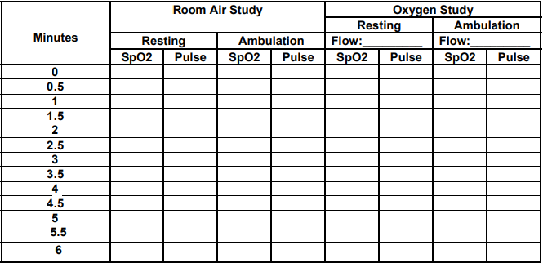

Comments: __________________________________________________________________________ Clinician’s signature: ______________________________Contact information__________________